Part 1
Listen to the conversations. Then write the type of book each person talks about.

mystery biography romance novel science fiction
thriller travel book autobiography short stories

Example: ____mystery___________

1.

2.

3.

4.

5.

6.

7.

Part 2
Choose the answer that completes each sentence correctly.

Example: I like thinking hard and figuring things out, so I love to .
[a. do puzzles] b. read aloud c. curl up

8. My husband and I are trying to decide how to decorate our living room. So I buy decorating magazines and to carefully study the ideas in them.
a. curl up b. skim through c. read e-books

9. My grandfather can’t see well anymore, but he loves books. So sometimes I .
a. listen to audio books b. do puzzles with him c. read aloud to him

10. This book is a that keeps you guessing all the time. You can’t wait to find out what’s going to happen next!
a. travel book b. cliff-hanger c. memoir

11. When I don’t have time to read an entire magazine, I to see which articles interest me most.
a. read it online b. skim through it c. listen to it

12. This book is a that’s perfect for a dull evening or two. It’s not very challenging, but it’s enjoyable.
a. best-seller b. cliff-hanger c. fast read

13. It’s taking me a long time to read this book because it’s .
a. hard to follow b. trash c. a page-turner

14. I love to when I’m driving because it makes the trip more fun.
a. read e-books b. do puzzles c. listen to audio books

Part 3
Check the correct sentences.

Example: □ We all think whether this comic is the best.
☑ We all think that this comic is the best.

15. □ I want to ask that he wrote another book.
□ I want to ask if he wrote another book.

16. □ Do you know where did Tina leave the magazine?
□ Do you know where Tina left the magazine?

17. □ I wonder if she liked the movie.
□ I wonder did she like the movie.

18. □ Did he like the food? I guess not.
□ Did he like the food? I don’t guess so.

19. □ I don’t know if we’ll be late, but I hope not.
□ I don’t know if we’ll be late, but I don’t hope so.

Part 4
Complete each sentence with an embedded question. Follow the example.

Example: Did Carla borrow my magazine?
I can’t remember _____if Carla borrowed my magazine_____.

20. How many poems did Pablo Neruda write?
I wonder .
21. Why do you want to read more books by that author?
I don’t understand .

22. Do you enjoy reading science fiction?
Tell me .

23. Who won the Nobel Prize for Literature this year?
Do you know ?

24. Whose book is this?
I’m not sure .

25. Where did you find a copy of that book?
I’d like to know .
.
Part 5
Read the book reviews. Then choose True or False for each statement.
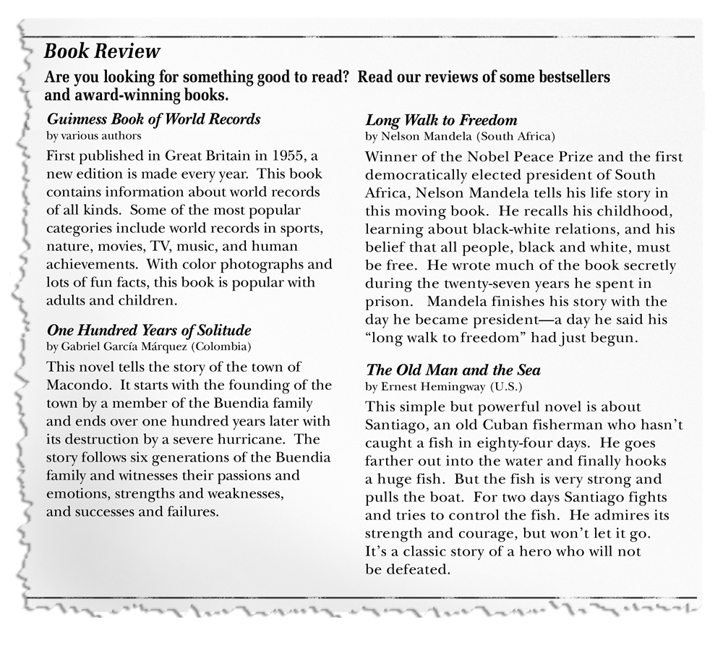

True False

Example: The Guinness Book of World Records is a collection of short stories. ( ) ( ✓ )

26. The Guinness Book of World Records is nonfiction. ( ) ( )

27. One Hundred Years of Solitude is a memoir about the Buendia family. ( ) ( )

28. Long Walk to Freedom is nonfiction. ( ) ( )

29. The Old Man and the Sea tells about a hero’s adventure. ( ) ( )

30. The Old Man and the Sea is nonfiction. ( ) ( )

Writing Test

Choose one of the following topics to write about. Write at least five sentences.

• What types of books/reading materials do you like and dislike and why?

• Discuss your reading habits.

Speaking Test

Talk about your favorite book. It can be one you read recently or one you read when you were younger. Tell the name of the book and who wrote it. Tell what the book is about. Finally, tell why you like it.

